
Symbiosis Institute of Technology, Pune
Faculty of Engineering
CSE- Academic Year 2026-27
Java Programming – Lab Batch 2024-28
Lab Assignment No: - 23
Name of Student: Sanika Botre
PRN No.: 25070122063
Batch: 2025-29
Class: CSE A-2
Academic Year & Semester: 2026 & 3rd Semester
Date of Submission
Title of Assignment: Develop a Java application using JDBC to navigate and retrieve records from a ResultSet.

Learning Objectives: To navigate and retrieve records using ResultSet methods.

Theory:

A ResultSet object contains data retrieved from a database after executing a SELECT query. It acts like a cursor that points to one row of the result at a time. Initially, the cursor is positioned before the first row. Various methods such as next(), previous(), first(), last(), absolute(), and relative() allow movement through the records. Data from each column can be retrieved using methods like getString(), getInt(), and getDouble(). Scrollable and updatable ResultSets provide greater flexibility for navigating and modifying retrieved data. ResultSet plays a crucial role in displaying and processing database information in Java applications.. Create a program to display database records one by one using ResultSet. 2. Create a Java program that retrieves employee records from a database and displays them one by one using ResultSet. Show employee ID, name, department, and salary sequentially
Practice questions
1. Create a program to display database records one by one using ResultSet.
Code:
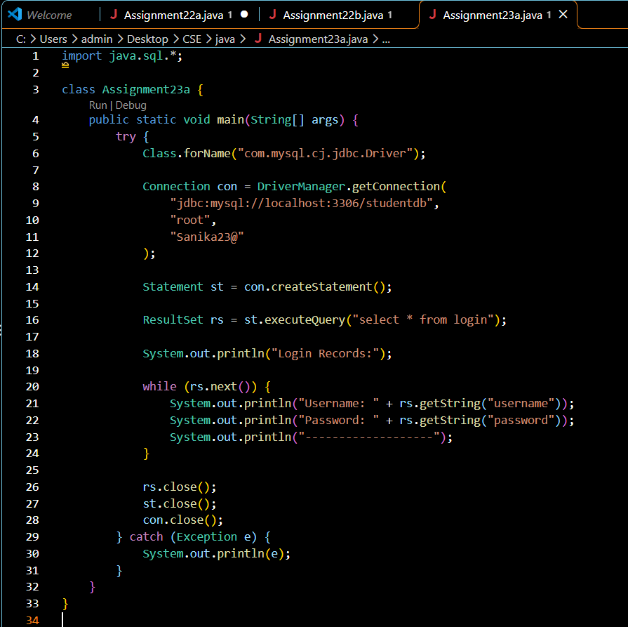
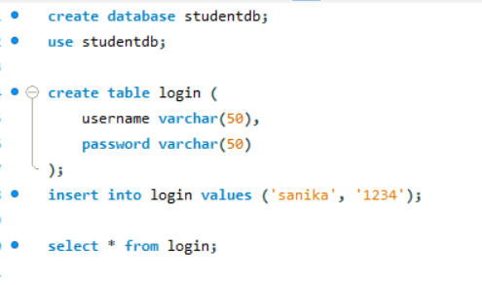

Output:
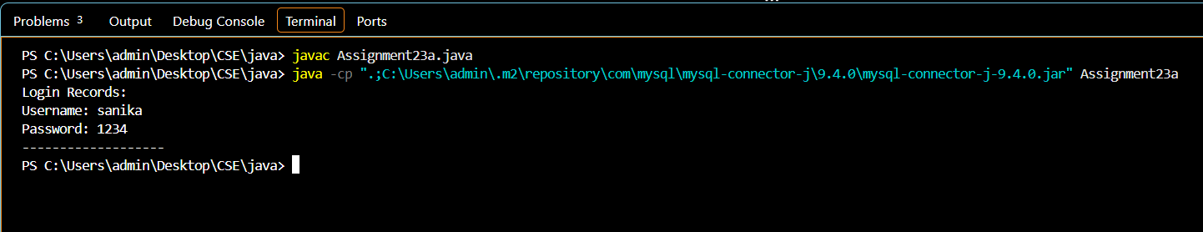

2. Create a Java program that retrieves employee records from a database and displays them one by one using ResultSet. Show employee ID, name, department, and salary sequentially
Code:

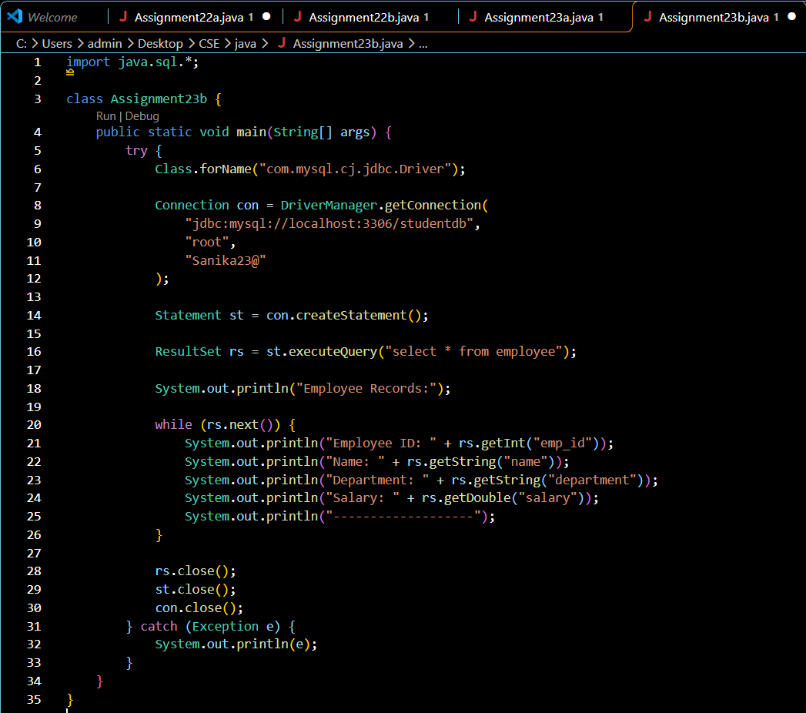

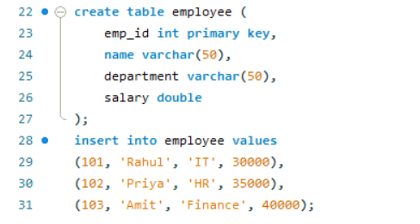

Output:

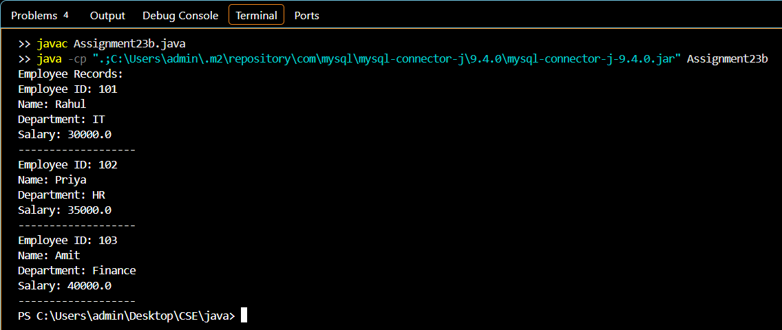

Conclusion
Thus, both programs were successfully implemented using JDBC and the ResultSet interface to retrieve and display database records. The first program displays login records, while the second displays employee details such as ID, name, department, and salary sequentially. This assignment helped in understanding database record retrieval and navigation using JDBC methods.

